Chapter 3, Solution 76

* Schematics Netlist *

I_I2 0 $N_0001 DC 4A
R_R1 $N_0002 $N_0001 0.25
R_R3 $N_0003 $N_0001 1
R_R2 $N_0002 $N_0003 1
F_F1 $N_0002 $N_0001 VF_F1 3
VF_F1 $N_0003 $N_0004 0V
R_R4 0 $N_0002 0.5
R_R6 0 $N_0001 0.5
I_I1 0 $N_0002 DC 2A
R_R5 0 $N_0004 0.25

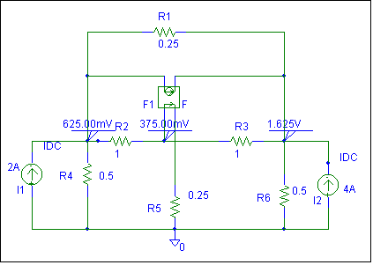

Clearly, v₁ = 625 mVolts, v₂ = 375 mVolts, and v₃ = 1.625 volts, which agrees with the solution obtained in Problem 3.27.

